Farhad Ahmed

Computer Networking

10/09/18

**Socket Programming Lab1: Web Server**

Running ifconfig:

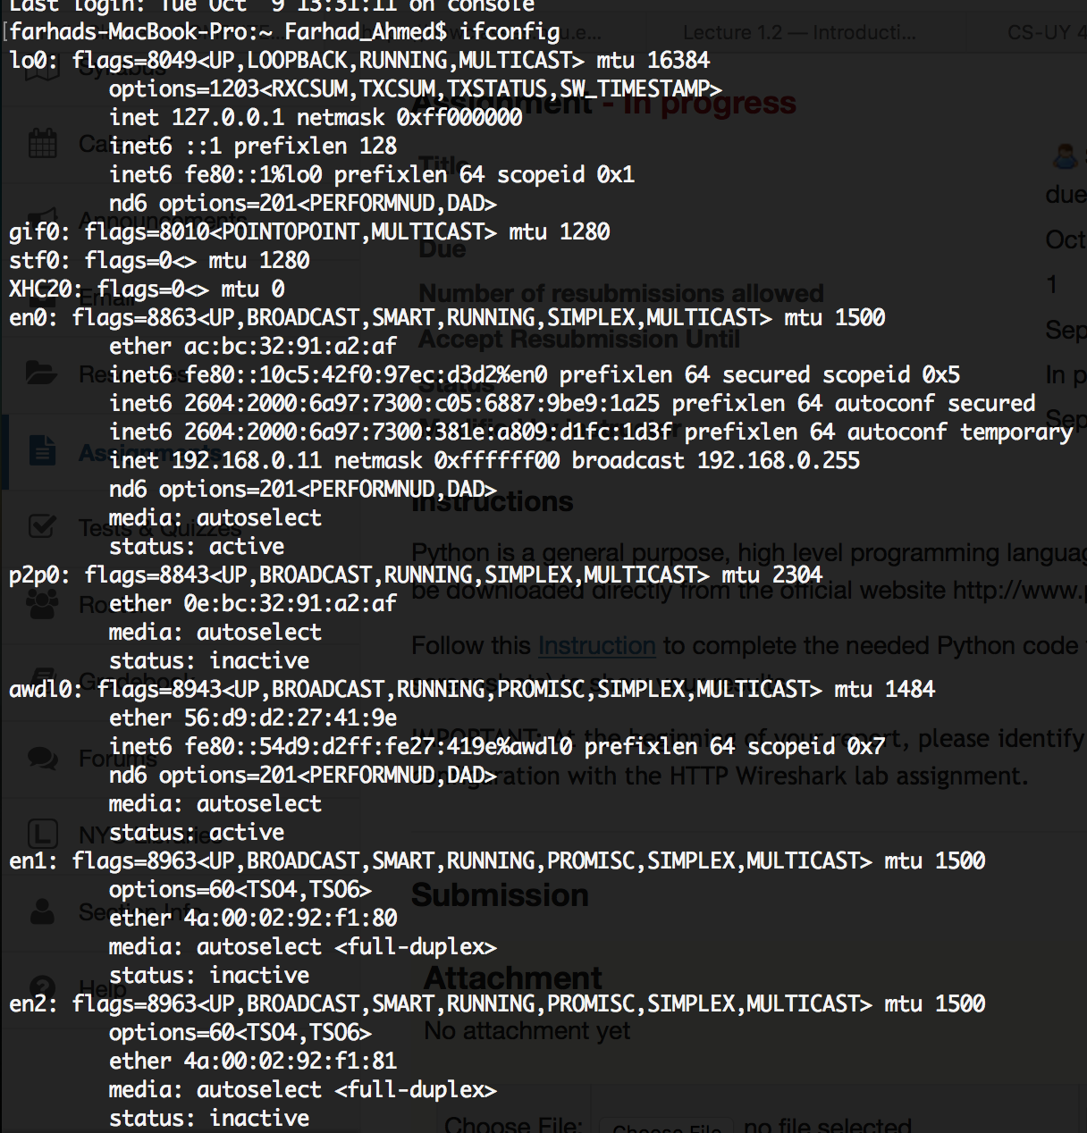

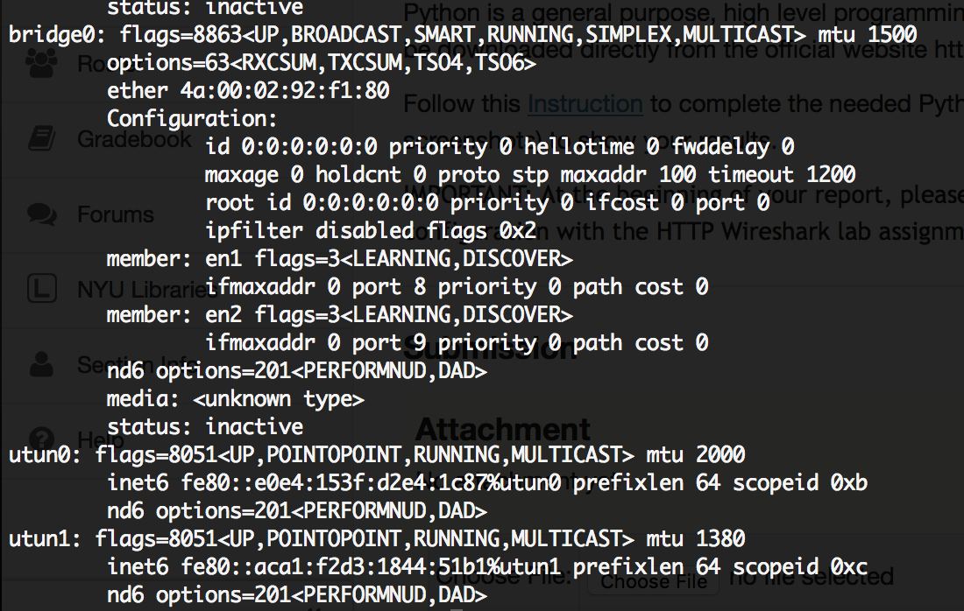

HelloWorld being served on the server:

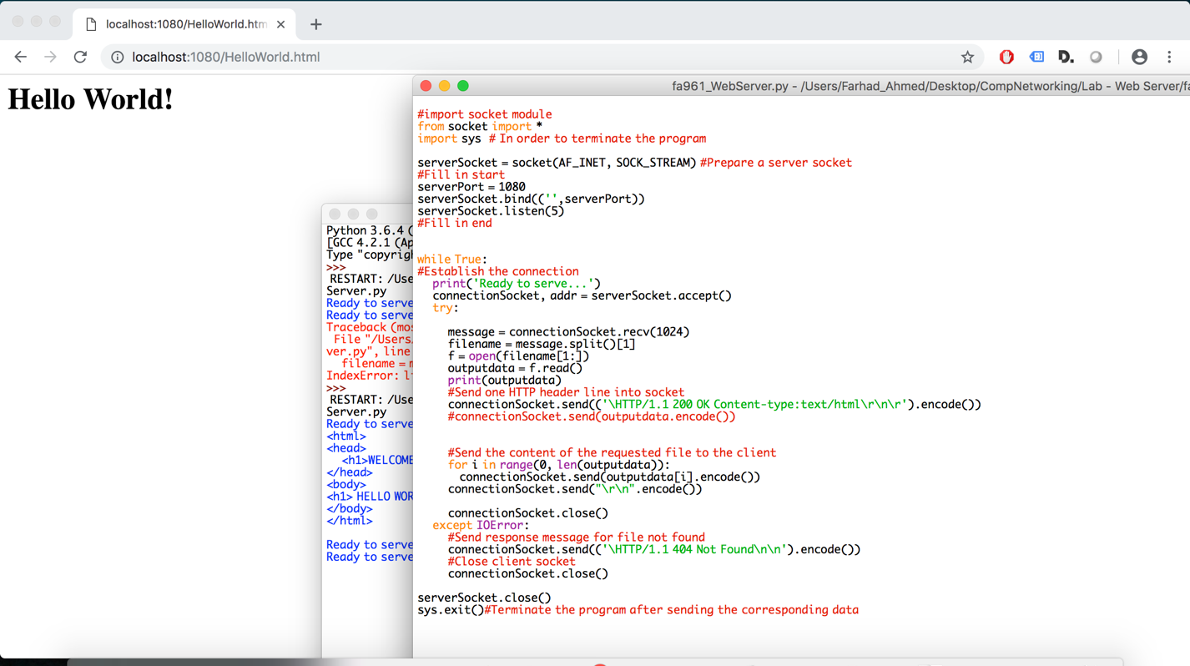

404 Error when trying to serve HelloWorlds.html:

